1. **Installing NodeJS** (skip this step if you've already installed NodeJS on your PC)
2. Install NVM (Node Version Manager): <https://www.geeksforgeeks.org/how-to-install-and-use-nvm-on-windows/>
3. Install NodeJS and NPM (Node Package Manager) via NVM. Following these commands to see and install specific Node versions

**nvm install [node version]** – install a version of Node.

E.g.: if you want to install the NodeJS version 12.13.0.

The command will be **nvm install 12.13.0**

**nvm list** – see the versions of Node you have installed on your machine

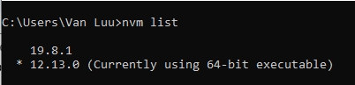

**nvm use [node version]** – use a specific version of Node.

E.g.: **nvm use 12.13.0**

1. **Install MongoDB Server**

Download here 👉 <https://www.mongodb.com/try/download/community>

* Just select the latest version and don’t forget to select the **Windows** platform and **msi** package before clicking on the **Download** button (see the screenshot below).

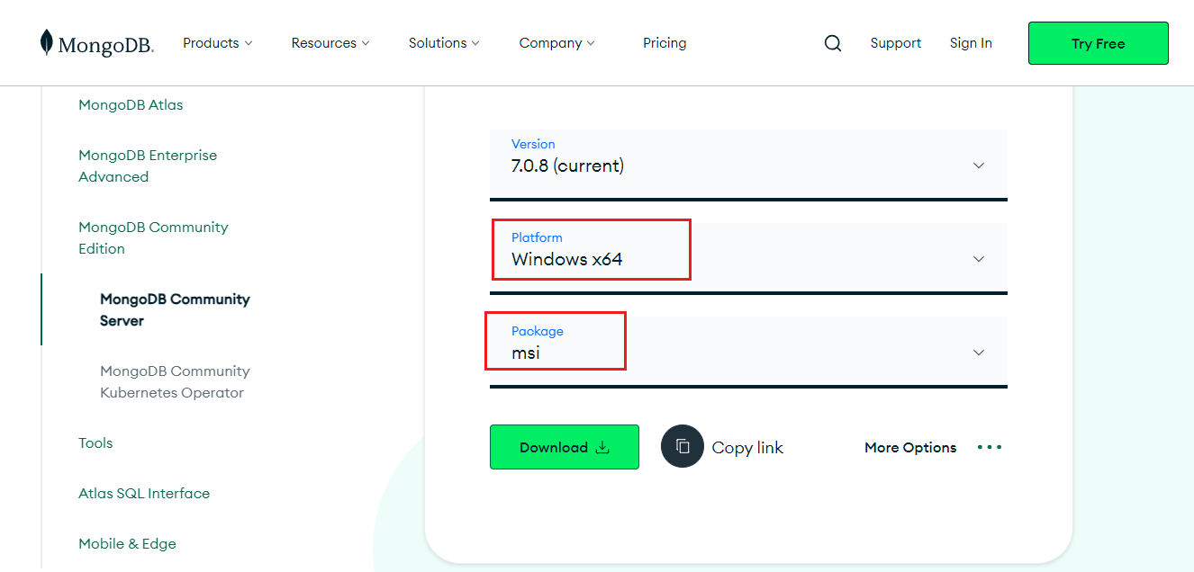

* After the download process is completed, let’s move on to install it. When you reach this step so clicking on the **Complete** button

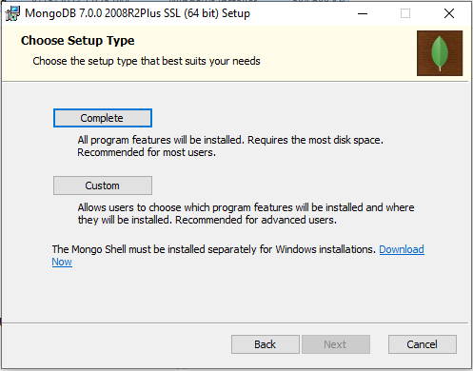

* Keep everything as default and **Next**, **Next** and **Next** and **Install**

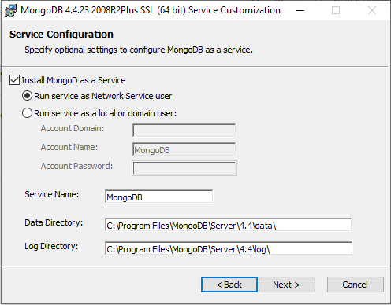

* After the install process is completed, it needs to be added to the Mongo’s bin folder to the Path Environment Variable.
* Find your Mongo’s bin folder at **C:\Program Files\MongoDB\Server\4.4\bin** and copy the path.
* Press window key, type “**env**”, Windows will suggest “**Edit the System Environment Variables**”, click that.

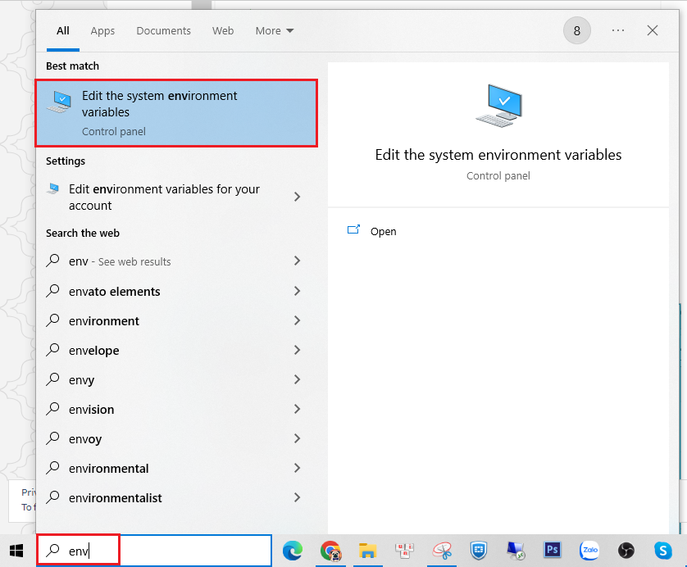

* Click on “**Environment Variables**”

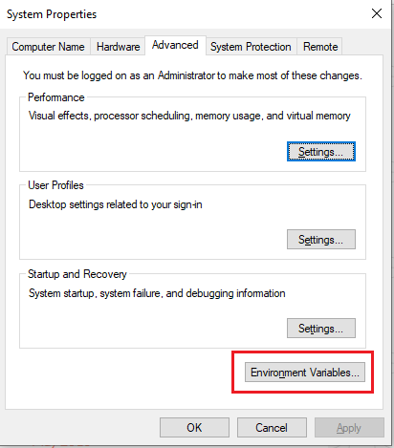

* Select “**Path**” and click on “**Edit**” button

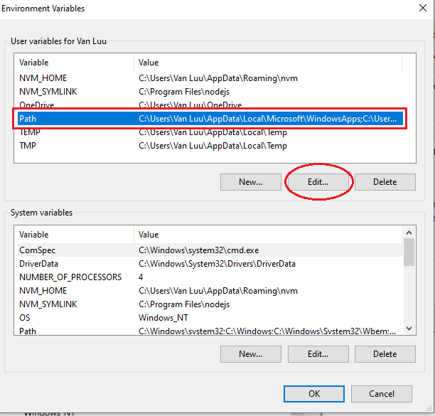

* Click on the “**New**” button and paste your path **C:\Program Files\MongoDB\Server\4.4\bin** here and then click on the “**OK**” button at the bottom to close all the windows.

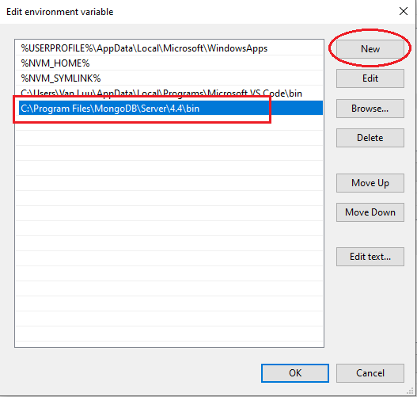

* Check the configuration by opening your terminal and run the command “mongod”. If you can see the result as the screenshot below, the configuration is completed. It’s time to move on 🙂

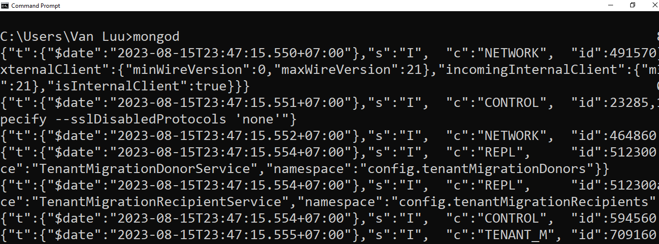

**Clone the code 👉** <https://github.com/luuthanhvan/CRM-MEAN-stack.git>